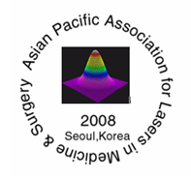

Asian Pacific Association for
Laser Medicne and Surgery
(APALMS)

Document About Exhibition Nov 11 ,2007
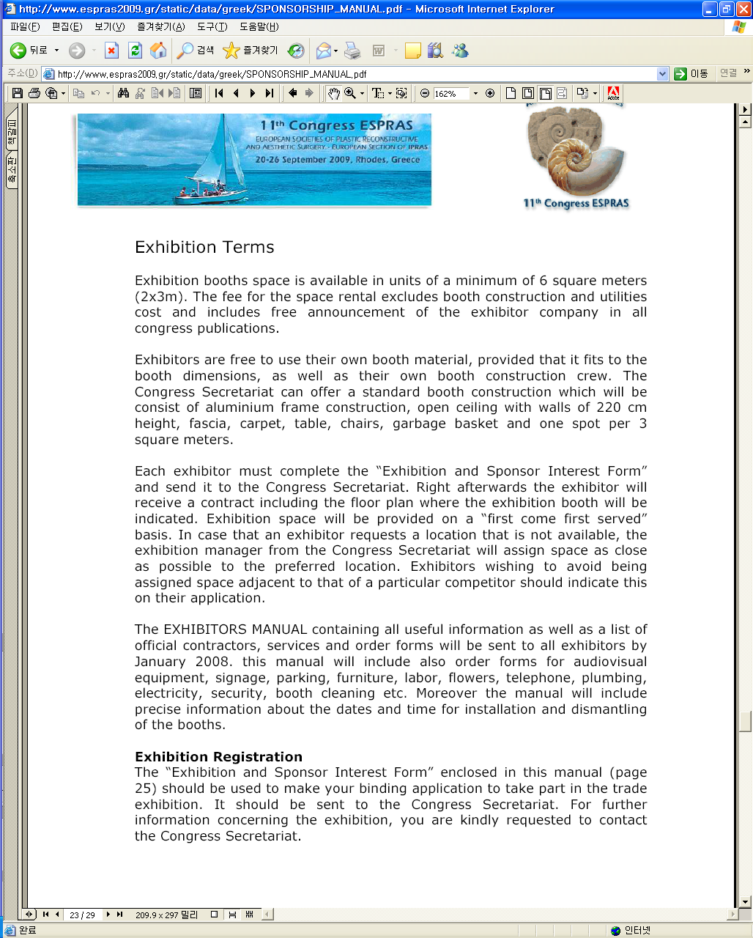
I would like to invite you next year seoul APALMS .

Fax (02) 517-3713 , H.P 011-775-3713 ( Area Code 82)
President of 12th Asian Pacific Association for Lasers in
Medicine and Surgery. Prof. Jin Wang Kim MD,PhD.
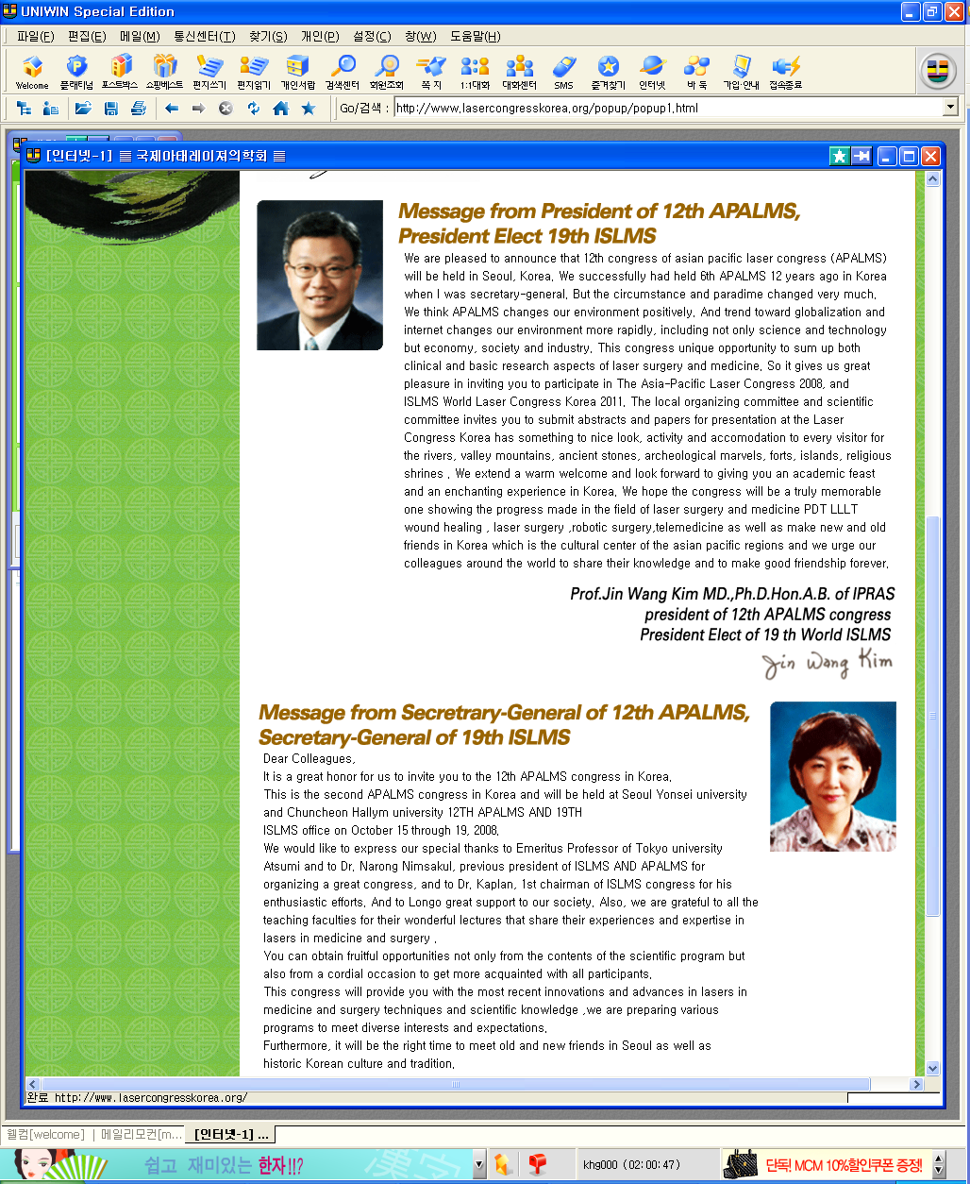
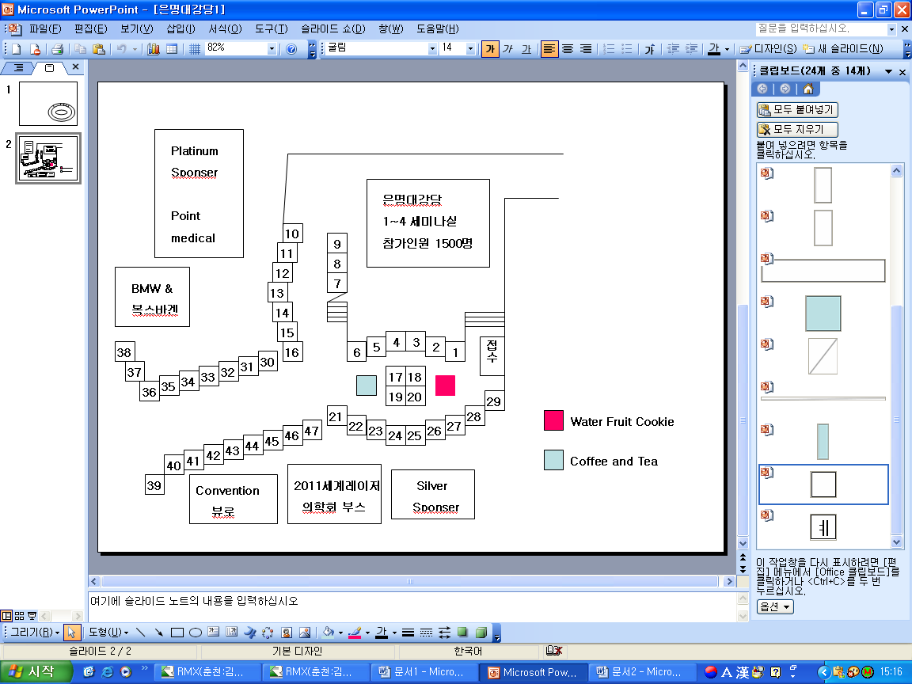
Eun Myung Auditorium
Registration and Exhibition : Thursday 12:00 pm~ Sunday 19:00 pm
. All laser beam must be turn down and regulate under the
laser safety ,Illumination must be regular & standard.

