Serial No.
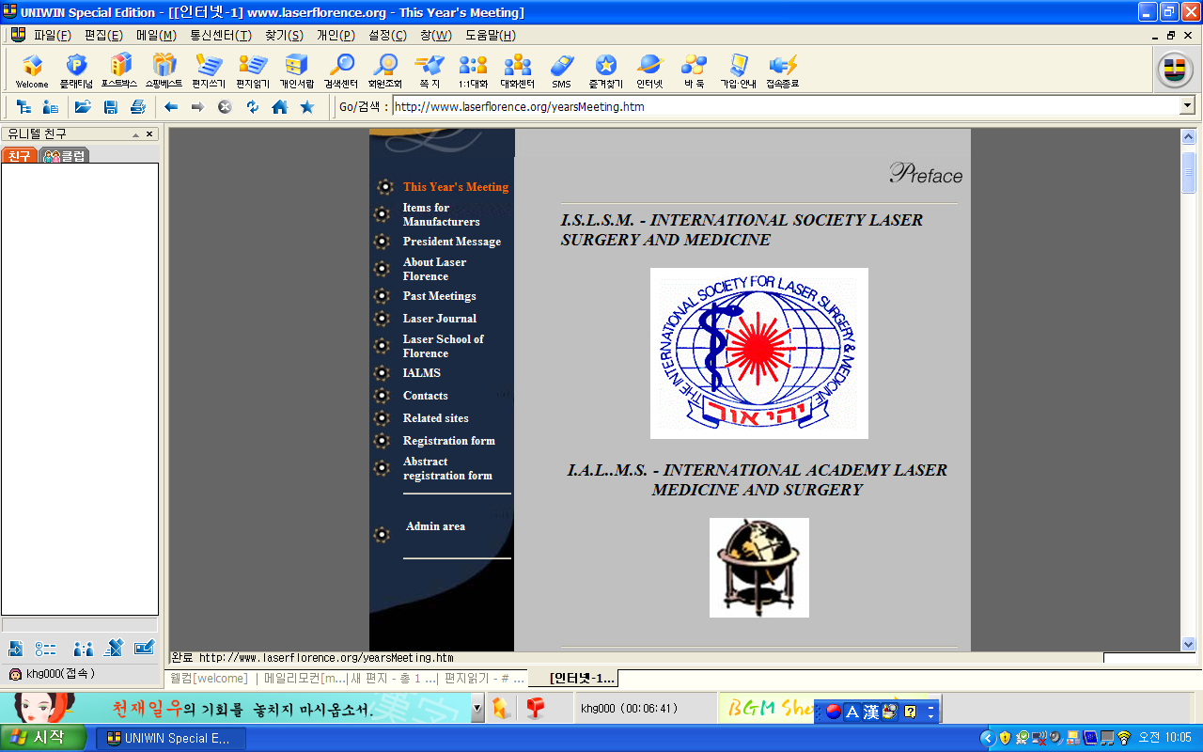
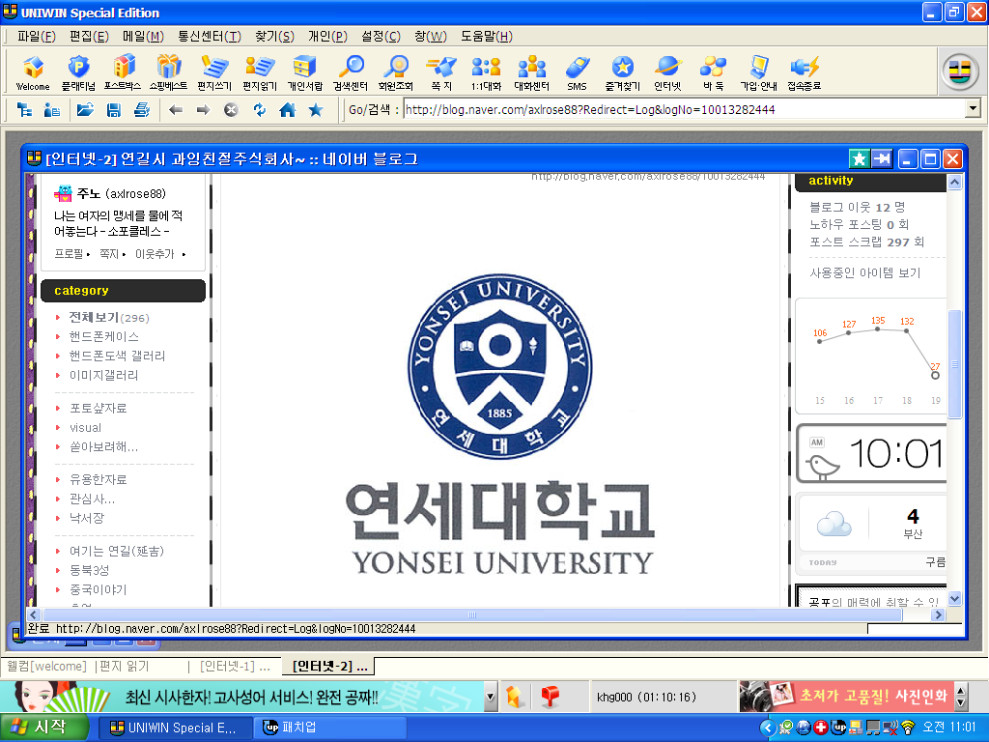
YONSEI UNIVERSITY LASER CONGRESS
SANG NAM INSTITUTE KOREA, SEOUL
GlOBAL MEDICAL CEO MBA FORUM

Certification of Attendance
This is certify that

Myung Ho Lee PhD

In Yonsei University Sang Nam Institute Global Medical MBA Course 2008
In Seoul,Korea October 16th~19th
^{AS INVITED}
CHAIRMAN OF THE BOARD ,MBA EXECUTIVE VICE-CHAIRMAN,DIRECTOR
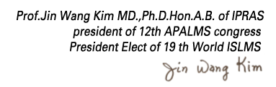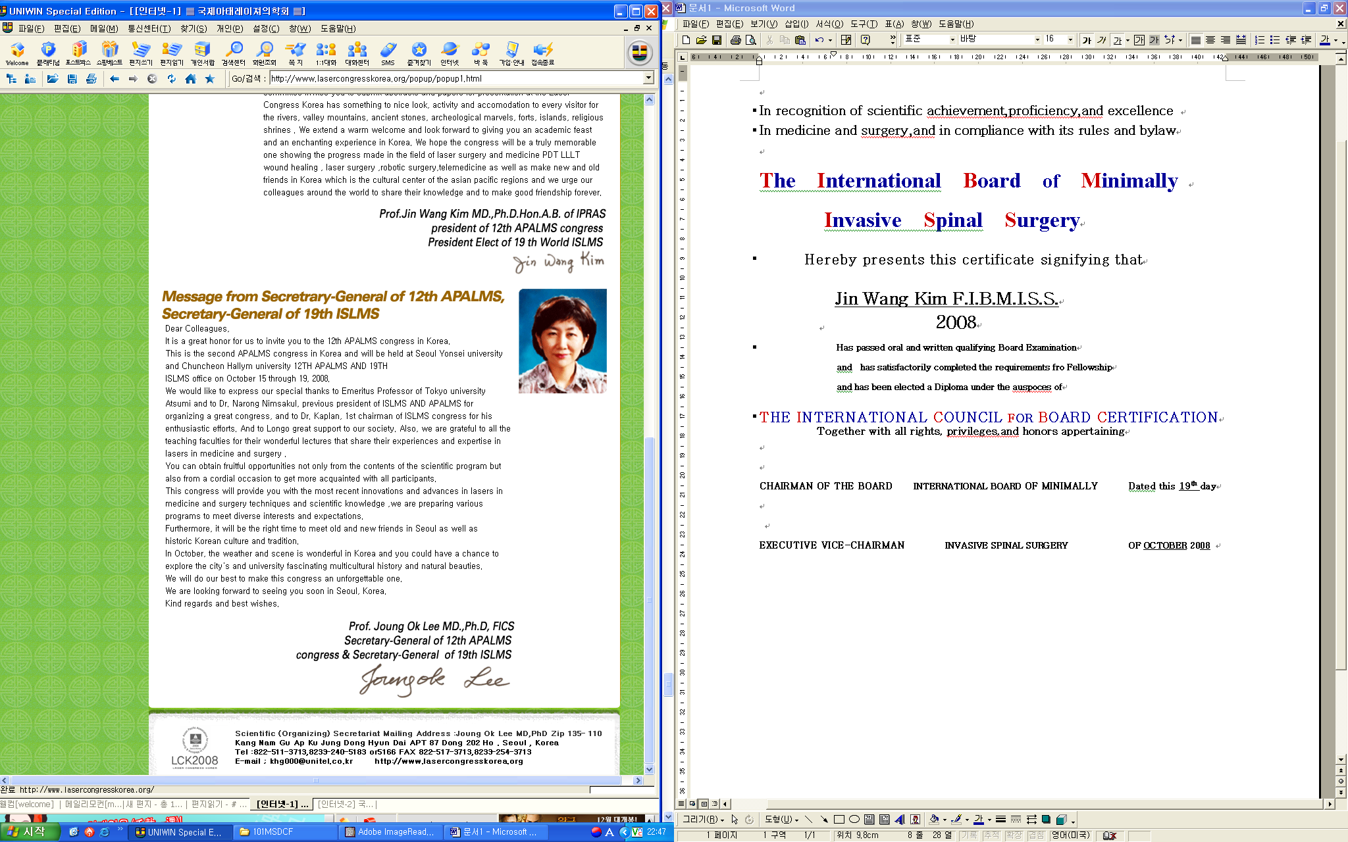
Serial No.

